Home Learning Year 3- WB 23rd January 2022
English |  | Completed by...
Spelling/Phonics: | Purple Mash activity and any spellings sent home.  There will be two spelling activities – one for Year 3 and one Year 2 spellings to recap. | Friday
Reading: | Read your school book  Myon reading task is The Simple Science of Soil  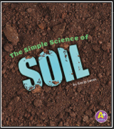  Remember to take the AR quiz after you have read the book. | Daily  Friday
Writing: | L.O. –  To create a story board about the Egyptian Cinderella | Friday
Maths:
Maths | TT Rockstars  Purple Mash - measure length and height | Daily
Curriculum
Foundation | Purple Mash activity  Beth on The Nile – Comprehension activity. | Friday

Don’t forget- we love seeing your home learning. You can always take a photo and email to school or tweet us! We are looking forward to seeing what you have been up to.

