Home Learning- Reception - WB: 17.05.21
English |  | Completed by...
Phonics: | If your child is in Miss Savage or Miss Bradshaw’s phonics groups play the video  to practise the digraphs ‘oo’ ‘oa’ ‘ar ‘  https://www.youtube.com/watch?v=af5mCjvLoSc  If your child is in Miss Seddon or Mrs Ali’s phonics groups play the video  to practise reading the ‘sh’ sound.  https://www.youtube.com/watch?v=7fE27v8n7Vw | Sunday 23rd May
Reading: | On See saw there is a non – fiction book about the life cycle of a chicken.  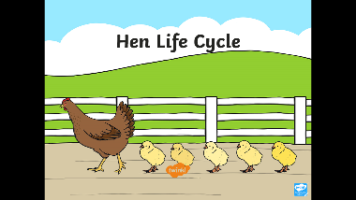  Enjoy reading the book together. Encourage your child to identify sounds that they know and blend them into words using their robot arms. They should also be able to spot some tricky words. Some of the words they will need your help with.  They should be able to tell you lots about the chicks that we have in school this week!  Can you post a video of your learning? | Sunday 23rd May
Writing: | This is the weeks Wonder picture.  It is on Seesaw for you to have a good look at!  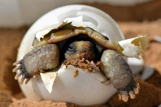  First can you say and write 2 I can see sentences. Remember to start saying and writing them with………….  I can see….  Then can you think about something you would like to know about the picture and say and write a wonder sentence. Remember to start it……  I wonder………………………  Can you post a picture of your learning? | Sunday 23rd May
Maths
Maths | Watch the video of First Then Now week 2 Day 1  https://whiterosemaths.com/homelearning/early-years/first-then-now-week-2/  Here is a direct link to the video  https://vimeo.com/543208191  Then complete the activity which is shown.  Can you post a video of photo of your learning? | Sunday 23rd May
Curriculum
On-going project | Can you draw us a picture of how you celebrated Eid?  Don’t for get to label it with the people who you saw and the things you did.  Can you send us a photo of your learning?  WE LOOK FORWARD TO SEEING YOUR IDEAS! | Sunday 23rd May
Home learning to be completed at any time throughout the week. All activities are set on seesaw, once they are completed we would like you to send it back to us on seesaw. If you have any questions you can send us a message through the inbox. Thanks, Miss Savage and Miss Bradshaw

