Learning Base 2 News
Spring 1 2020
We are ready for a new year and a term full of exciting learning.
Our new topic……..Gardens
During our topic this half-term we will be looking at ‘Gardens’. We will be looking at the different gardens that are in our local area and what gardens are in our country and other countries.
We shall be looking at, naming and labelling the different features within gardens.
We will also be looking at and talking about where we live and what we like and dislike about the local area. We will have several walks to the local park to look at how our surroundings change through time.

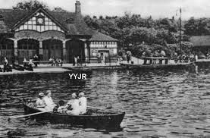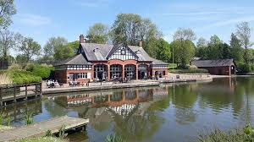
How you can help at home…
*PLEASE continue to talk about what you notice in the world around you and what is happening in the country that you live. Please also continue to talk about what they are learning in school as this really embeds their learning.
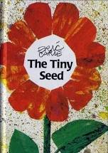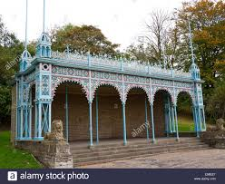
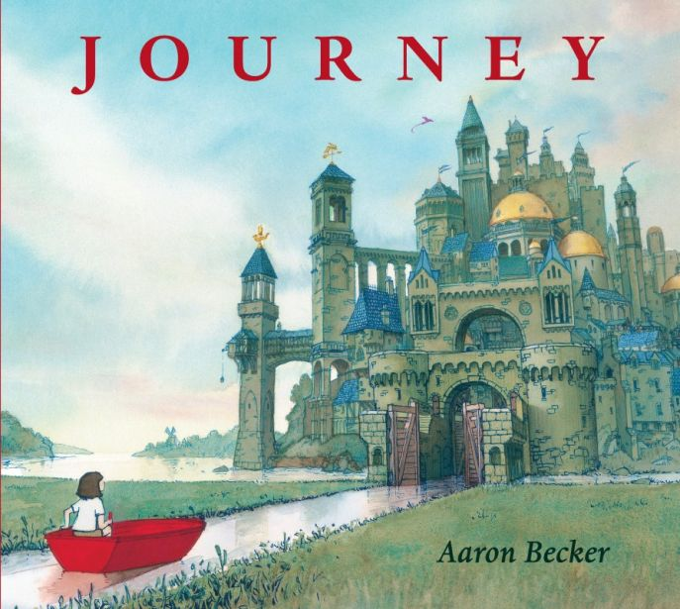
In Literacy…
The children will be looking at fiction and non-fiction books about ‘Gardens’. They will learn about what seeds need to grow as well as learning about different life cycles.

How you can help at home…
*Read every day with your child. This can be reading the story to them and asking questions to check their understanding or asking them to tell you the story from the pictures.
*Give your child the opportunities to talk about what they have done during school and write in the home diary things from the weekend. They provide talking points with your child.
*Go to the library and share the class books and others.

In Maths
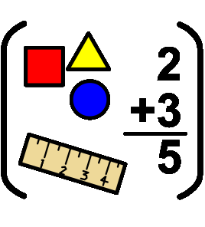
The children will continue to look at recognising numbers and learning how to count objects then adding and subtracting them. We will also be learning about 2D and 3D shapes and creating different patterns with them.
The children will be looking at length and height of different objects as well as learning about weight.
The children will also be learning about money.

How you can help at home…
- Encourage your children to read numbers they see around them and count using fingers.
- Model counting when setting the table, playing games, walking (number of steps), counting cars.
- Make up maths problems for your children to solve eg. If I have 10 biscuits and give 3 to my friend, how many will I have left?
- Talk about and compare objects you find around your home eg. Which is the heaviest, lightest, tallest, shortest, longest?
- When you go to the shops, encourage your child to look at how much things cost and involve them in paying money for them.

Reminders
Make sure you share your child’s reading book with them at home and that your child brings their book bag to school EVERY DAY.
Inform school if you have any appointments.
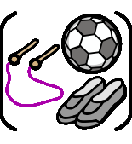
Games will be on a Wednesday and P.E will be on Thursday. Please make sure they have a white t shirt and black shorts/joggers and pumps or trainers.
PE kits can stay in school all week as the children will also regularly take part with other physical learning eg. Pirate island, working towards walking the daily mile.
Could all parents please bring in a full change of clothes in a labelled bag
Thank you for your continued support.

