Home Learning Year 3 WB: 25.4.22
English |  | Completed by...
Spelling: | All Spellings are on Purple Mash.  Spellings are Year 3 and Year 2 spellings. Some children will also have Year 1 spellings to complete. If your child has personal targets they may also have High Frequency Words or phonics spelling tasks.  Please continue to practise your Common Exception Word Spellings.  Though, notice, quarter, length,  Library, famous, describe, mention,  answer, appear | Friday
Reading | MyON – Books will be added every week. When you know your book, please do your AR quiz.  Remember after you have read the books we have set you can browse and search for other books you would like to read!  Read your reading book every night and make a list of any words you are not sure about. You can quiz on your schoolbook on the AR website.  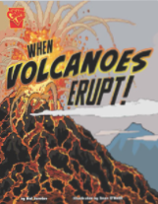 | Daily
Writing: | Instruction writing  Learning Objective: Word Aware  SC: To use a dictionary to find the definition. | Friday
Maths
Maths | TT Rockstars – who will win the battle? Class 7 or Class 8? Can you get your heat map greener? Just 10 minutes a day can make a big difference.  Purple Mash tasks  Addition and subtraction - Fact families | Friday
Curriculum
Topic | Purple Mash activity.  Choose a picture of a volcano and write a description of it.  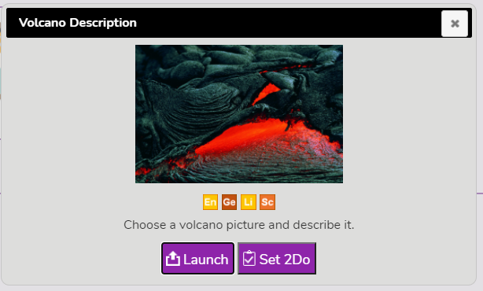 | Friday

Home learning to be completed by Friday. Thank you.

