Home Learning Year 3 WB: 9.5.22
English |  | Completed by...
Spelling: | All Spellings are on Purple Mash.  Spellings are Year 3 and Year 2 spellings. Some children will also have Year 1 spellings to complete. If your child has personal targets they may also have High Frequency Words or phonics spelling tasks.  Please continue to practise your Common Exception Word Spellings.  Though, notice, quarter, length,  Library, famous, describe, mention,  answer, appear | Friday
Reading: | MyON – Books will be added every week. When you know your book, please do your AR quiz.  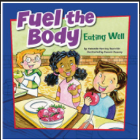  Remember to browse or search for books you are interested in.  Read your reading book every night and make a list of any words you are not sure about. You can quiz on your schoolbook on the AR website. | Daily
Writing: | Word aware  Learning Objective: To use a dictionary to find the definition | Friday
Maths
Maths | TT Rockstars – who will win the battle? Class 7 or Class 8? Can you get your heat mat greener? Just 10 minutes a day can make a big difference.  Purple Mash - Addition and Subtraction - related number facts. | Friday
Curriculum
Topic | 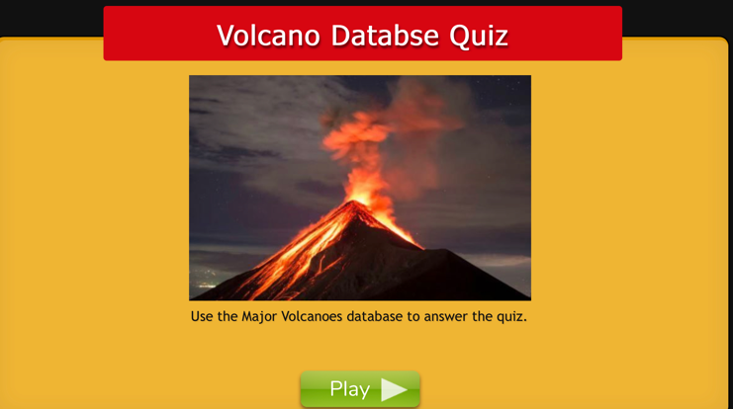  Purple Mash activity. | Friday

Home learning to be completed by Friday. Thank you.

