MyOn Guidance for Parents
Your child has now been given MyOn details however if they have trouble logging on, please ask them to speak to their class teacher. The website is www.myon.co.uk. This is a new resource that we will be using in school but will also be expecting the children to use at home. MyOn is an online library where children have access to a range of books. This is a great tool to develop their love of reading. Every week, your child’s class teacher will set them a homework project which is to be completed online. The class teacher will mark this project when it has been handed in and give feedback to the children individually.

How to browse books:
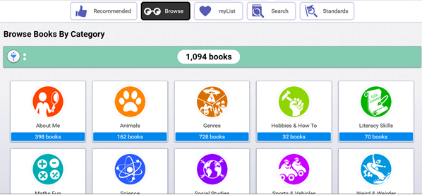

Click on library. To find a book that your child would like to read, select browse which breaks the books down into categories or they can select search where they can enter a key word and the relevant books will appear. All books will be age appropriate for that children once they log in.

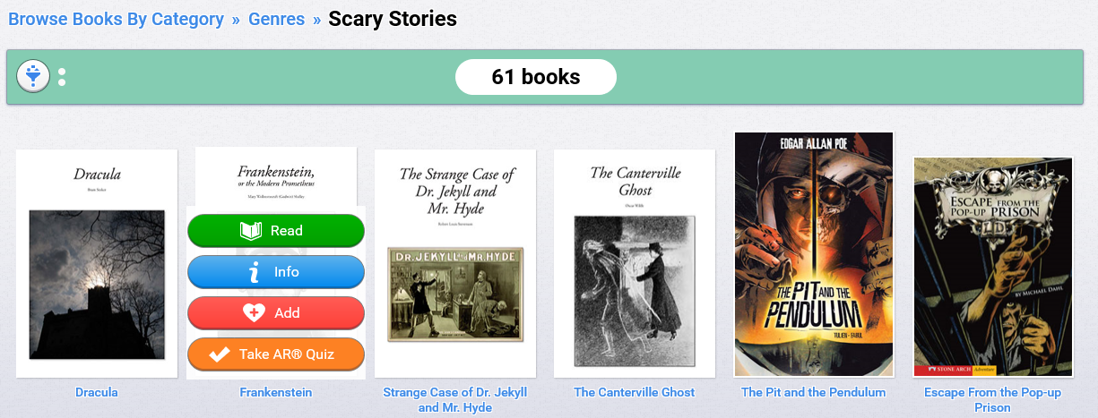
When they find a book that they like the look of, if they hover over it, four options will appear.
Info – Gives brief synopsis of the book
Add – They can add any book to their own library and develop a bank for the future.
Take AR Quiz – This will link to their AR account and they can take the quiz as soon as they have finished.
If they children decide to read that book, this is what will appear on their screen:
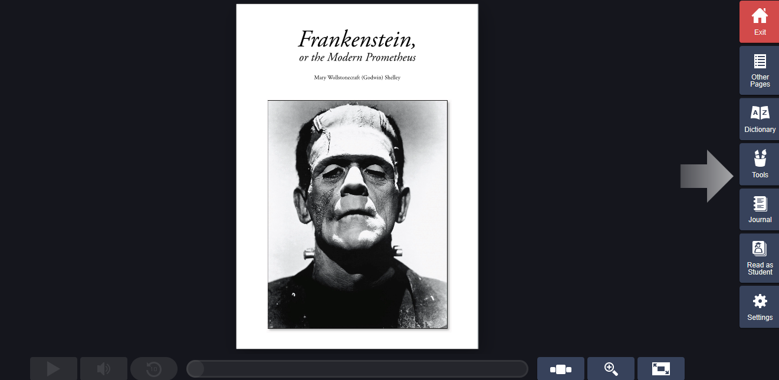

Underneath the front cover of the book there will be an option of audio if it is available which means the book can be read to your child. For the book that I have selected, this tool is not available.

Down the right hand side of different tools that the children can use when reading the book.
Dictionary – This is where the children can type in a word that they are unsure of the meaning of and the definition will come up or when reading, they can click on an unknown word and it will take them to the dictionary.
Tools – This is where they can add sticky notes to the page if they want to make notes, highlight phrases or words, underline anything etc. This would be a good tool to use for when they have been set a project
Journal – This is where children can start journaling about the book that they are reading.
When they children have finished their reading for the day, click exit and it will automatically save the page number and any additional notes that they have made.
Completing projects set by class teacher:
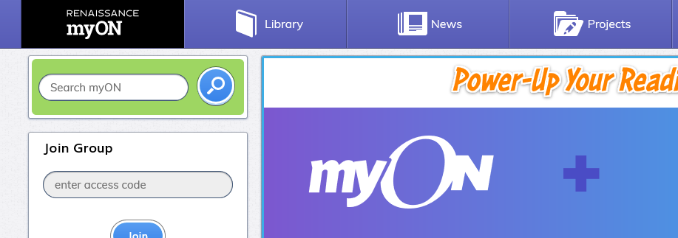

When your child logs on, click on ‘projects’. This is where all of the projects will be that the class teacher set. Your child will be told when they have been set and when they are due back.

