Home Learning – Learning Base 2- wk beg – 28th September 2020
English |  | Completed by...
Speaking and Listening | During Literacy the children will be looking at different pobble 365 pictures related to the topic. Please talk to your child about these pictures, describe what they see and ask and answer questions to gain more information.  This week the picture is Pobble picture- https://www.pobble365.com/doors/  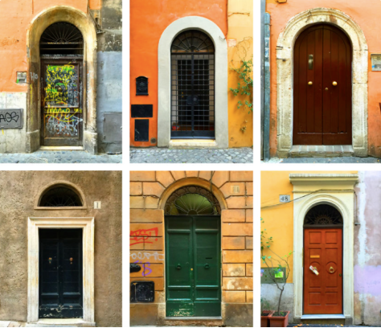  Look at the doors  What do you notice?  What shapes and colours can you see on the doors?  Describe what you see – “I see a big green door with rectangles and squares on it”.  What might be on the other side of the door? Who lives there? | 2nd  October
Spelling/  Phonics: | Please use the phoneme mat previously provided to recap the sounds that your child recognises. Take turns with your child to say and find different sounds.  Please practice your child’s full name so that all the letters are formed correctly. Please use the RWI sheet provided in your home learning pack.  Practice writing all the letters of the alphabet. Say the letter name and sound.  Websites to support phonics learning  *https://www.verywellfamily.com/best-free-educational-websites-for-kids-3129084  -Sesame Street - letters  - Starfall- sounds  - Phonicsplay - https://www.phonicsplay.co.uk  *https://www.topmarks.co.uk/ - games for sounds  *https://www.ictgames.com/ - games for literacy
Reading: | Please share your child’s reading book. Take turns to read to each other. Please talk about the pictures and what is happening in the story.  Please continue reading the ORT books that have been sent home.  Please listen, share and ask questions about the book.  - Bugclub - Please log in and read the books that have been selected for your child at their level of learning - Username and Password previously sent.  - Purple mash - Please log and in complete selection of activities. Username and password given in home learning packs  Register and access free books - https://home.oxfordowl.co.uk/reading/reading-schemes-oxford-levels/read-write-inc-phonics-guide/ - parents to use for home learning  https://www.oxfordowl.co.uk/
Writing: | Please practice your child’s full name so that all the letters are formed correctly. Please use the RWI sheet provided in your home learning pack.
Maths:
Maths | When you are walking home from school, look at the door numbers  Which numbers do you recognise?  Practice writing numerals to 10.  Order the numbers 1-10. Remove a number and find the missing number. Find 1 more than and 1 less than.  Practice recognising numbers. Show any numeral for your child to say. What is one more than and 1 less than.  Please continue to practically count out amounts of objects. Look at the numerals 1-20 and count out the correct amount of objects.  Extend by adding and subtracting numbers up to 10.  Websites to support maths learning  *https://www.verywellfamily.com/best-free-educational-websites-for-kids-3129084  - PBS Kids - counting songs  - Starfall - counting  - CoolMath - all maths concepts  *https://www.topmarks.co.uk/ - games for maths  *https://www.ictgames.com/ - games for maths
Curriculum
Topic | This half term the children will be learning about ‘who lives in a family and where they may live and what they may do’.  Please draw  - A picture of what your house looks like
On-going project- | The children will be talking about where different families live.  The on-going topic this half term will be to create a model of a home that a family may live in.  This could be their own home OR research different homes that families across the world may live in, then create a model of a home.

Don’t forget-
We love seeing your home learning. You can always take a photo and email to school or tweet us! We are looking forward to seeing what you have been up to.

