Home Learning Reception - WB 12th October 2020
English |  | Completed by...
Spelling/Phonics: | We will be teaching phase 2 phonics this week with the sounds s/a/t/p/i/n  https://www.youtube.com/watch?v=DIpcahxNSU4  This is a video to demonstrate each sound we will be teaching during phase 2 and how to pronounce them correctly.  https://www.youtube.com/watch?v=euxN7LGOoLc  When teaching the children a new sound we will also teach them the Jolly Phonics action, please encourage your child to complete the actions whilst joining in with the singing.  Complete the sound sorting sheet attached. | Friday 16/10/2020
Reading: | Your child has a reading book in their book bag, please practise reading it with them at least three times a week.  This week we have been reading a non-fiction book, Homes Around the World.  Here is a link to a video of the book.  https://www.youtube.com/watch?v=cjO9Jg5H9-4  Watch the video and ask your child what unusual places to live they can remember from the book. What similarities and differences can they see between their own home and the ones in the book?  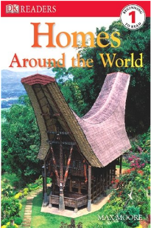 | Friday 16/10/2020
Writing: | Please work with your child to write their name independently. Whilst your child is writing their name please encourage them to use the correct pencil grip and form their letters correctly. | Monday 19/10/2020
Maths:
Maths | This week in maths we have been making sets of objects and writing numbers. Can you give your child a number between 1 and 10 and get them to draw a set of that number of objects? | Monday 19/10/2020
Curriculum
The World | This week we have been thinking about our ideal home. Can you draw and label what your ideal home would look like on the sheet below? | Monday 19/10/2020
On-going project- | We would like to know all about your family for our topic of ‘Being Me in my world’– Can you draw us a picture of all the people in your house and label it? | Ongoing
Don’t forget- we love seeing your home learning. You can always take a photo and email to school on info@greenhill.theharmonytrust.org or tweet us @Greenhill_HT We are looking forward to seeing what you have been up to!
Thanks, Miss Savage and Miss Bradshaw
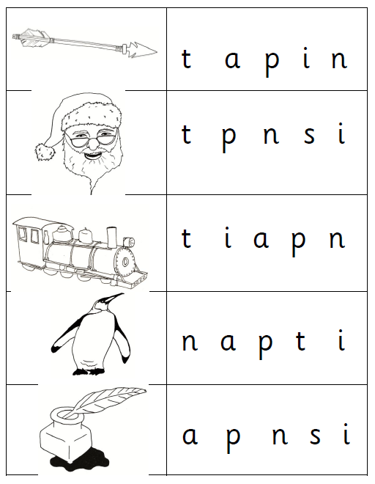

Circle the correct start sound of each of the pictures.

