Home Learning – Learning Base 2- wk beg – 19th October 2020
English – Communication (Speaking and listening)

Monday | During Literacy the children will be looking at different pobble 365 pictures related to the topic. Please talk to your child about these pictures, describe what they see and ask and answer questions to gain more information. This week the picture is  Pobble picture- https://www.pobble365.com/journey-to-school/  What do you notice?  Resources –Pobble picture
Tuesday | Do you think the children in the picture find the journey to school difficult?  What do you think their school is like? How might it be similar/different to yours?  Who are the adults in the picture? What do you think they are carrying?  Resources –Pobble picture, I can see bubble and Concept in Print pictures (CIP) (to extend the language from yesterday)
Wednesday | Where in the world do you think the children are from?  How do you think these children would react to spending a day at your school? How would you react to spending a day at theirs?  Resources – Pobble picture
Thursday | If you could have your dream school, what would it look like and what would you do at your ideal school?  Draw your dream school.  Resources – Pictures of different schools in different countries
Friday | Describe your school  Resources – Pictures of different schools in different countries and CIP pictures used to describe
Spelling/ phonics

Monday | Please use the phoneme mat provided to recap the sounds that your child recognises.  Take turns with your child to say and find different sounds.  Resources – Phoneme mat (alphabet)
Tuesday | Look at the individual letters, say the sound and find/match to the phoneme mat  Resources – Phoneme mat (alphabet) / individual letters
Wednesday | Using the individual letters, play find the ____ game. Place some of the letters out and say “find me the ____”, child collects  Resources – Individual letters
Thursday | Use the sounds / m / a / s / d / t / i / n / p / g / o /  Sound out / m / a / p / map. Child to make / m / a / p / map  Resources – words - - in/ on/ it/ an/ and/ pin/ got/ dog/ sit/ tip/ pan/ gap/ dig/ top/ nap/ pop/ pat/ pig/ not/ gap/ ip/ op/ sop/ gip/ pog/
Friday | Say the words for your child to make  Map, sat, pin, got, mit, mop,  Child will listen, say the sounds in order and make the word  Resources – words, individual letters
Websites to support phonics learning
https://www.verywellfamily.com/best-free-educational-websites-for-kids-3129084
- Sesame Street - letters - https://www.sesamestreet.org/games
- Starfall- sounds - https://www.starfall.com/h/
- Phonicsplay - https://www.phonicsplay.co.uk
https://www.topmarks.co.uk/ - games for sounds
https://www.ictgames.com/ - games for literacy
Writing

Monday | Please practice your child’s full name so that all the letters are formed correctly.  Please use the RWI (alphabet) sheet provided in your home learning pack.  Say the letter formation as you write the letter eg. “round the apple and down the leaf” when writing the letter /a/.  Say the letter and sound of the letters in your child’s name. They will form the letter correctly.  Resources – RWI letter formation sheet, child’s name card
Tuesday | Say a letter and sound. Child to form the letter correctly.  Practice writing all the letters of the alphabet. Say the letter name and sound.  Resources – RWI letter formation sheet
Wednesday | Use the words from spelling for your child to write.  Resources – words to write – map, tin etc
Thursday | Using the dream school that you have drawn and described, look at the words and write on your picture to describe the school – big, red, glass, children, toys etc  Resources – CIP words to write the words to describe their dream school
Friday | Write sentences to describe your dream school  “My school is made of glass”  “ My school is near the seaside”  “ My school is big”  Resources – CIP words to support ideas
Reading

Monday | Please continue reading the ORT books that have been sent home.  Please share your child’s reading book.  Please talk about the pictures and what is happening in the story.  Resources – reading books
Tuesday | Please listen, share and ask questions about the reading books sent home.  Talk about who is in the story? what is happening?  What do they think will happen next?  Look at the initial letters and read the text in the book  Resources – reading books
Wednesday | Bugclub - Please log in and read the books that have been selected for your child at their level of learning - Username and Password given  Resources – https://www.activelearnprimary.co.uk/login?c=0
Thursday | Register and access free books - https://home.oxfordowl.co.uk/reading/reading-schemes-oxford-levels/read-write-inc-phonics-guide/ - parents to use for home learning  Resources - https://www.oxfordowl.co.uk/
Friday | Myon free books. Please log in and look at the books available.  Share the books  Resources – www.myon.co.uk.
Maths

Monday | When you are in the different rooms of your house, COUNT the things you see  How many plates are on the table?  How many pieces of cereal did you have for your breakfast  Count whilst you are brushing your teeth – what did you count up to?  Resources – counting objects in the environment
Tuesday | Look at the number line. Say the numbers in order whilst tracking them.  Practice recognising numbers. Show any numeral for your child to say and find on their number line. What is one more than and 1 less than.  Resources – Individual numerals and 1-20 number line
Wednesday | Order the numbers 1-10. Remove a number and find the missing number. Find 1 more than and 1 less than. Use numbers 1-20 when confident with 1-10  Resources – individual numeral and number lines
Thursday | Practice writing numerals to 10 and numerals 1-20  Say a number, child finds on the number line and writes the numeral  Resources – number lines
Friday | Please continue to practically count out amounts of objects. Look at the numerals 1-20 and count out the correct amount of objects.  Extend by adding and subtracting numbers up to 10.  Resources – Number lines, individual numerals , objects
Websites to support maths learning
*https://www.verywellfamily.com/best-free-educational-websites-for-kids-3129084
- Jack Hartman count to 100 -
- PBS Kids - counting songs - https://pbskids.org/
- https://www.starfall.com/- counting
- CoolMath - all maths concepts
*https://www.topmarks.co.uk/ - games for maths
*https://www.ictgames.com/ - games for maths
Curriculum
Music | The music service have added lessons online. Go to https://www.GMmusiconline.co.uk/yumu  Enter your username and password in the boxes on the screen.  Your username is: p1351527 Your password is: symphony
Topic | This half term the children will be learning about ‘who lives in a family and where they may live and what they may do’.  Look on google maps and find your house  Please draw a picture of your house in your street
On-going project- | The children will be talking about where different families live.  The on-going topic this half term will be to create a model of a home that a family may live in.  This could be their own home OR research different homes that families across the world may live in, then create a model of a home.
Sensory
Playdough | Follow the guidance on Dough disco - https://www.youtube.com/watch?v=3K-CQrjI0uY
Meditation
Peaceout | Follow the peaceout video - https://www.youtube.com/watch?v=2TFuFd4iFOY

Don’t forget-
We love seeing your home learning. You can always take a photo and email to school or tweet us! We are looking forward to seeing what you have been up to.

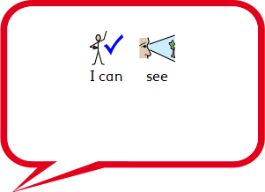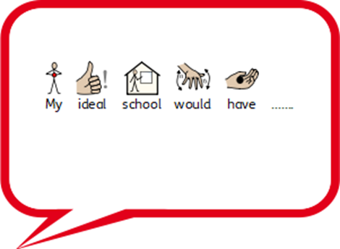

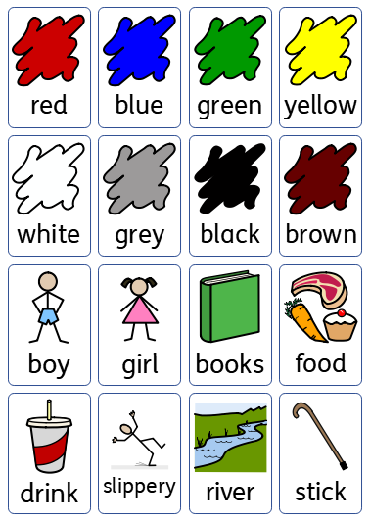

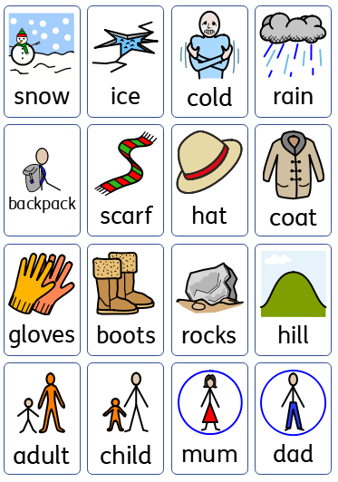

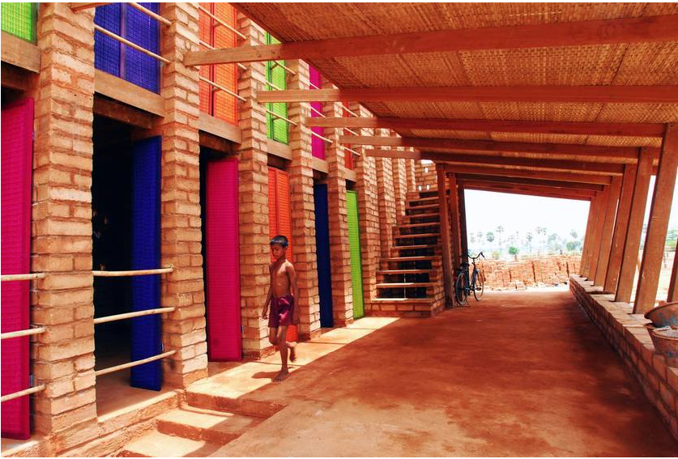  A rainbow-inspired school in Cambodia  The Sra Pou vocational school in Cambodia was entirely handmade out of local materials with a local workforce. | 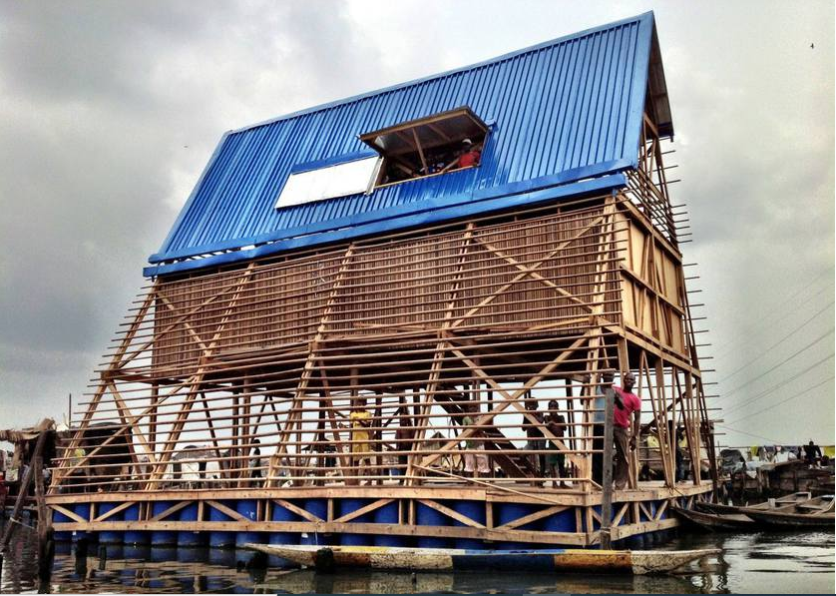  A floating school in Nigeria  Makoko Floating School is a half-building and half-boat prototype for African regions that have little or no permanent infrastructure, thanks to unpredictable water levels that cause regular flooding.
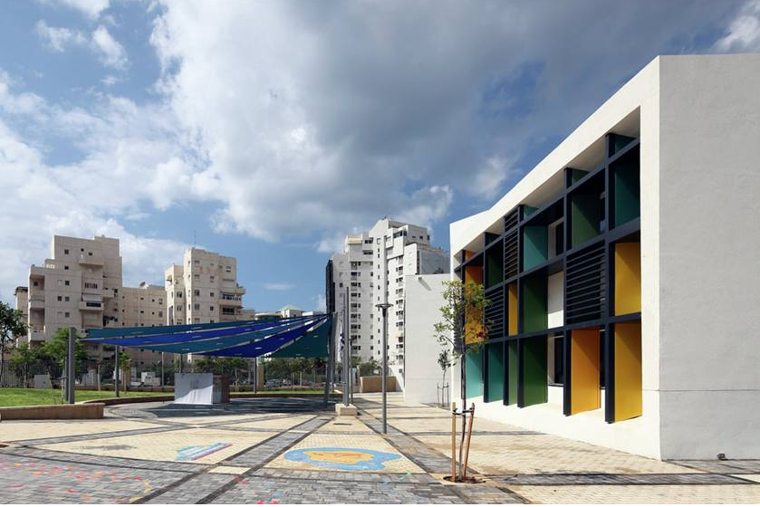  Using color creatively in Israel  In Tel Aviv, Israel, there's an elementary school with innovative design whose clever use of color promotes creativity. Outside, the school's demure white façade is a tribute to "The White City" of Tel Aviv. | 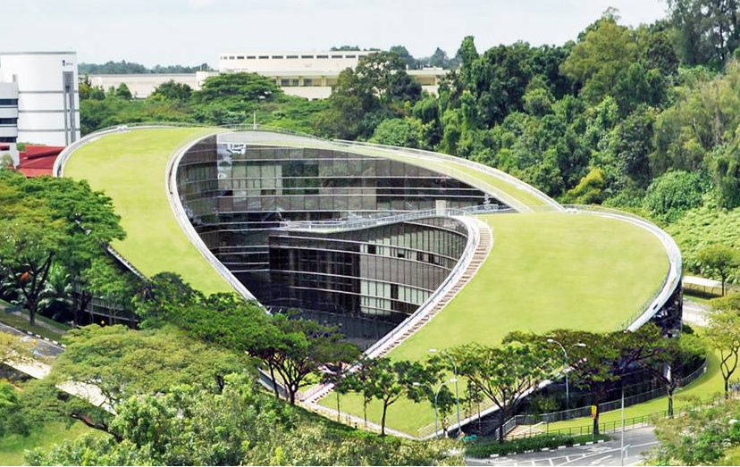Eco-friendly art school in Singapore  One of the most remarkable green roofs we've seen is at the School of Art, Design and Media at Nanyang Technological University in Singapore.
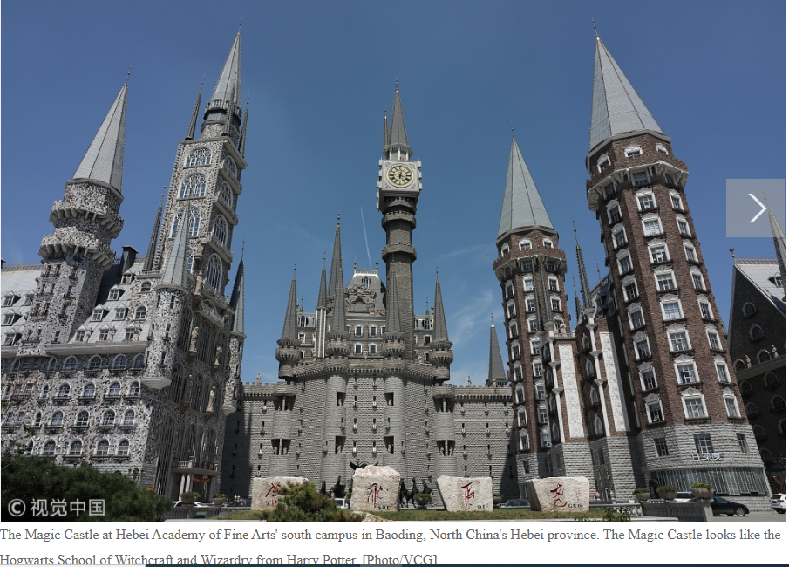 | 