Home Learning Reception- WB: 2nd November 2020
English |  | Completed by...
Spelling/Phonics: | What things can you find that start with the sounds s,a,t,p,I,n?  Can you colour the initial sound of the object shown on the learning sheet?  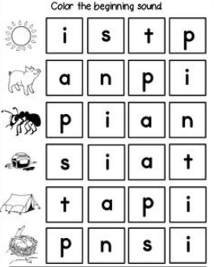 | Thurs5th November
Reading: | Please read with your child at least 3 times this week and when you have done this write in their yellow Reading Diary so your child can get stickers from their teacher to celebrate their great reading.  Can you share your favourite book with a grown up at home?  What is your favourite part of the book? | Ongoing all week
Writing: | Can you write your name? Please practise writing your child’s name with them using the correct pencil grip and the correct letter formation shown on the sheet below.  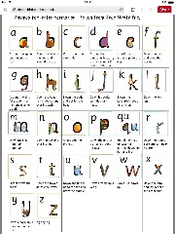  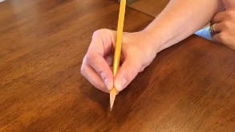 | Every day
Maths:
Maths | This week we have been doing lots of learning about 2D shapes. What shapes can you find around your home? Can you find and draw some 2d shapes that you can see in your home?  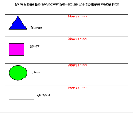 | Every day
Curriculum
The World | This week we shall be doing lots of learning about Autumn and what makes it different from the other seasons. Can you talk to your child and help them to draw and label some of the sign of Autumn on the learning sheet? | Monday 9th November

Don’t forget- we love seeing your home learning. You can always take a photo and email to school or tweet us! We are looking forward to seeing what you have been up to.

