Home Learning Year 3- WB: 16th November 2020
English |  | Completed by...
Spelling/Phonics: | 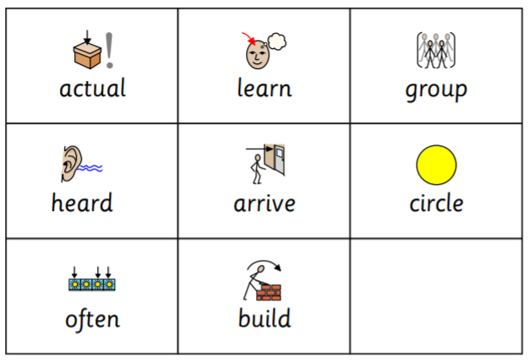 | Sunday
Reading: | Read your school book  MyON – Read the book ‘Teasing isn’t Funny’ Think about how this relates to our E-Safety Day. Is there someone in school or at home that you could be kinder to?  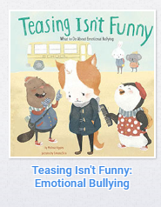. | Daily  Sunday
Writing: | Can you draw a label a Stone Age camp? What would you expect to find there? What would people be doing? Write a short story about your Stone Age camp. | Sunday
Maths:
Maths | TT Rockstars  Purple Mash time tables activities. | Daily  Sunday
Curriculum
One curriculum area to be selected a week | Purple Mash. French activity. Can you practise the names of family members ready for next week’s French lesson? ‘Voici’ means ‘here is’. | Sunday
On-going project- | Our on-going project is the Stone Age.  Read the facts here and watch the videos to boost your knowledge.  https://www.bbc.co.uk/bitesize/topics/z82hsbk/articles/zpny34j

Don’t forget- we love seeing your home learning. You can always take a photo and email to school or tweet us! We are looking forward to seeing what you have been up to.

