Home Learning Reception- WB:16th November 2020
English |  | Completed by...
Spelling/Phonics: | What things can you find that start with the sounds g, o, c, k?  Can you match the images and words on the learning sheet using your robot arms to blend the sounds into words? Cut out the pictures and stick them in the correct box  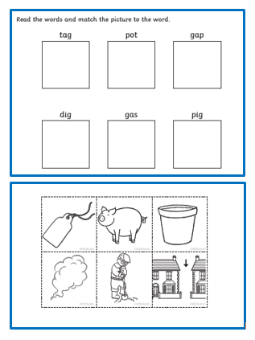 | Thurs19th November
Reading: | Please read with your child at least 3 times this week and when you have done this write in their yellow Reading Diary so your child can get stickers from their teacher to celebrate their great reading.  Can you share your favourite book with a grown up at home?  What is your favourite part of the book? | Ongoing all week
Writing: | Can you write your name? Please practise writing your child’s name with them using the correct pencil grip and the correct letter formation shown on the sheet below.  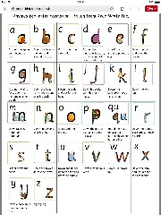  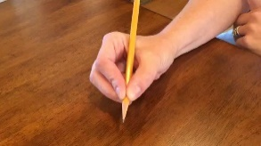  Can you practise writing the letters we have learnt in phonics this week - g o c k?There are some sheets attached to help you ! | Every day
Maths:
Maths | This week are doing lots of learning about 4 and 5. Can you find lots of different ways to represent the number 4? There is a sheet attached to help you!  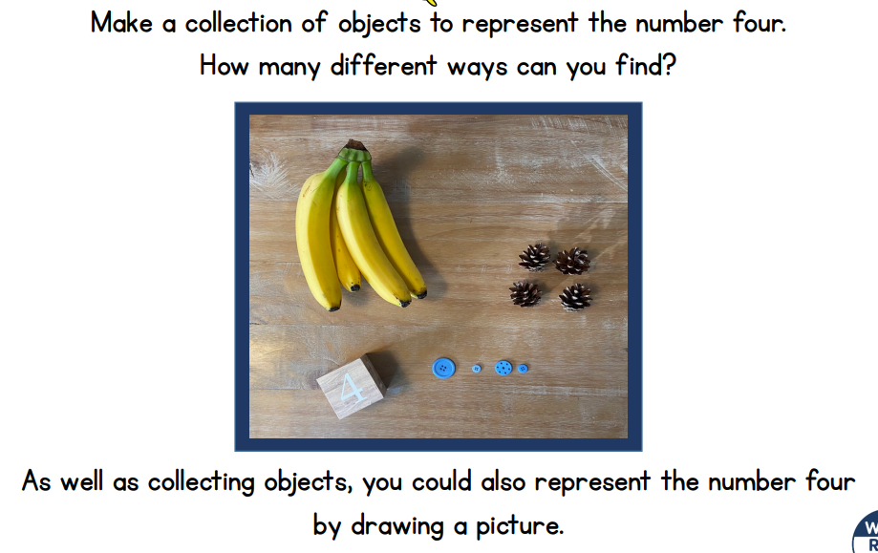 | Monday 23rd November
Curriculum
The World | This week we shall be doing lots of learning about Nocturnal animals. How many nocturnal animals can you find in the word search? You may need to help your child to show them how a word search works!  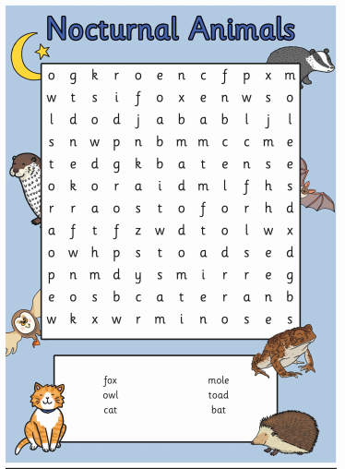 | Monday 23rd November

Don’t forget- we love seeing your home learning. You can always take a photo and email to school or tweet us! We are looking forward to seeing what you have been up to.

