Home Learning Reception- WB:30th November 2020
English |  | Completed by...
Spelling/Phonics: | This week in phonics we will be introducing the children to the sounds b,f,l https://www.bbc.co.uk/bitesize/topics/zcqqtfr This is a link to a phonics BBC bitesize page with videos to demonstrate each sound we will be teaching during phase 2 and how to pronounce them correctly. In phonics we are looking at lots of CVC words with the children such as cat and dog. We name each sound we can see in the word and then say them using robot arms to try and get the children to orally blend the word. Get them to show you how we do it. | Thurs 3rd December
Reading: | Please read with your child at least 3 times this week and when you have done this write in their yellow Reading Diary so your child can get stickers from their teacher to celebrate their great reading.  Can you share your favourite book with a grown up at home?  What is your favourite part of the book?  Attached to your home learning pack is your Bug Club Password and login. On this interactive site you will find books for your child to read linked to their current phonics phases and some fun activities. There is a parents section to show you how to help your child. | Ongoing all week
Writing: | Can you write your name? Please practise writing your child’s name with them using the correct pencil grip and the correct letter formation shown on the sheet below.  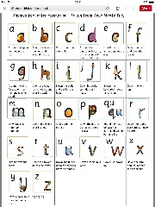  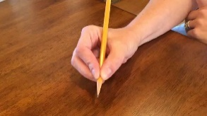  Can you practise writing the letters we have learnt in phonics this week - There are some sheets attached to help you ! | Every day
Maths:
Maths | This week we have been doing lots of learning about shapes. Can you help your child to colour in the shapes in the right colour on the sheet? Ask them how many sides and corners each shape has as they are identifying the shapes. | Monday7th ^{r} December
Curriculum
The World | This week we have been doing lots of learning about sorting day and night time activities…..  Can you sort the images into day and night time activities? | Monday 7th December

Don’t forget- we love seeing your home learning. You can always take a photo and email to school or tweet us! We are looking forward to seeing what you have been up to.

