Isolation Home Learning: WB 11^{h} January 2021
Spelling/Phonics |  | Time to spend on activity
Spelling/Phonics: | How to start each session:  Please re-cap Phase 2, Phase 3, sounds using the word mats provided.  Practice reading and writing the high frequency words provided in your learning pack, as well as regularly practicing tricky words using the tricky words songs:  https://www.youtube.com/watch?v=TvMyssfAUx0  Start your child off with group 1 phonics. If they are finding this too easy then please move onto group 2 – Phonics.  Group 1 - Phonics  Monday: Phonics: Phonics: new sound of the day: Y  Read and Spell these words:  yap, yet, box, yes, fix, yet, yuck, yum, yes, yell. Can you think of anymore?  Practise reading : ‘he, we, me, be’  Write the sentence – Has a fox got six legs? (Discuss what is a question mark used for?)  Tuesday: Phonics: Phonics: new sound of the day: z  Read and Spell these words:  zip, zit, Zak, zigzag - Can you think of anymore?  Practise reading : ‘he, we, me, be’  Write the sentence – Has a cat got a web (Discuss what is a question mark used for?)  Wednesday: Phonics: Phonics: new sound of the day: zz  Read and Spell these words:  buzz, fizz, jazz, fuzz, - Can you think of anymore?  Practise reading : ‘he, we, me, be’  Write the sentence – Can a duck quack? (Re-cap - what is a question mark used for?)  Thursday: Phonics: Phonics: new sound of the day: Alternative sound qu  Read and Spell these words:  quiz, quit, quick, quack, quid - Can you think of anymore?  Practise reading : ‘will, was’  Write the sentences –  - Is a lemon red?  - Has a fox got six legs?  - Has a cat got a web?  Friday- Writing simple sentences  Re-cap all of the sounds you have learnt this week. Have a go at writing some simple sentences using the sounds you have practiced  Group 2 - Phonics  Monday: Phonics: Phonics: new sound of the day: ar  Read and Spell these words:  bar, park, card, jar. - Can you think of anymore?  Practise reading ‘she’ and ‘all’  Write the sentence – Mark and Carl got wet in the rain  Tuesday: Phonics: Phonics: new sound of the day: or  Read and Spell these words:  for, fork, cord, cork - Can you think of anymore?  Practise reading ‘was’, ‘will, with.’  Write the sentence – The farm has a big tree.  Wednesday: Phonics: Phonics: new sound of the day: igh  Read and Spell these words:  high, sigh, light, night, tight, might, right, sight - Can you think of anymore?  Practise reading: was’, ‘will, with.’  Write the sentence – The night is not light.  Thursday: Phonics: Phonics: new sound of the day: ur  Read and Spell these words:  fur, burn, burp, curl - Can you think of anymore?  Practise reading: ‘look’ and ‘too.’  Write the sentence – The chimpanzee sat in the tree.  Friday- Writing simple sentences  Re-cap all of the sounds you have learnt this week. Have a go at writing some simple sentences using the sounds you have practiced  Try using phonics play daily to test your phonic understanding through using some fun games. https://www.phonicsplay.co.uk/resources  Lots of these games are free to play.  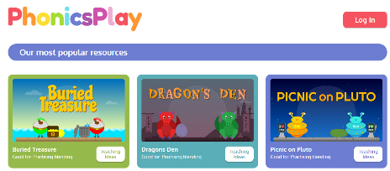  Ensuring we have capital letters, finger spaces and question marks in all sentences. /?/ Can you write some questions. | 30 minutes
Reading | Remember to read your reading book with a family member at least 3 times throughout the week. Try re-telling the story to check if your chid has understood what has happened in the story and see If they can remember any characters.  Remember to read your reading book with a family member at least 3 times throughout the week. Try re-telling the story to check if your chid has understood what has happened in the story and see If they can remember any characters.  This week we love you to log onto the Oxford owl reading website to access lots of different types of books for FREE! Use the link below to access the website:  Click on ‘My Bookshelf’ to access a range of different books for you to share.  Use the link below to access the website:  https://www.oxfordowl.co.uk/  Click on the ‘My class Login’ button   Then, enter the details below for BOTH Class 3 and Class 4:  My Class name: class3_GH  Password: Greenhill1  Questions to ask when reading at home  - What is the story about?  - What did the character just do? Why?  - What do you think will happen next?  - Who is your favourite character? Why?  - What is your favourite part of the story? Why?  Using the template attached write a book review of your favourite story from the week using the website above. Continue to read the reading books provided in your book bag. | Read for 15 minutes daily using your oxford owl login.  30 minutes
English
Monday | LO: To Retell and Recall  (There is no teacher video for Monday’s session. Simply listen to the story using the video link below)  Opener: Begin by looking at the cover of the book ‘Handa’s Surprise’ Where do you think the story is set? Who do you think the little girl is? Where do you think she is going? What do you think she has in her basket?  Main: Using the link below listen to the story.  https://www.youtube.com/watch?v=AJdPlMebjAw  Think about the answers to the above questions. Where you right?  Activity  Find a small cardboard box or small plastic basket. Draw pictures of the fruits and put them in the basket. Place the basket on your head and walk around like Handa. Have a go at being Handa and retelling the story to a family member. | 45 minutes
Tuesday | LO: To sequence  (Remember to watch the teacher video available to help you with this session)  Opener: There were eight animals and eight pieces of fruit in the story. Can you remember their names?  Main: Can you remember who took the first piece of fruit? Can you remember who took the fruit second, third and so on? The video will help you to put the animals in order.  Activity  Log onto Purple Mash. Look at the pictures from the story. Sequence them into the correct order. Have a go at writing a sentence about each picture. | 45 minutes
Wednesday | LO: To write simple sentences using adjectives  (Remember to watch the teacher video available to help you with this session)  Opener: Watch the teacher video and think about or talk about the following things.  - What does Handa’s basket look like? (yellow, golden, made of straw, large)  - Without naming the fruit, say what kind of fruit she put in her basket? (sweet, delicious, colourful)  - How does she walk to her friend’s house? (slowly, carefully, quietly)  Main: Watch the teacher video, which will help you to write sentences about the beginning of the story.  Activity  Log onto Purple Mash. Have a go at writing sentences about what Handa does at the beginning of the story. | 45 minutes
Thursday | LO: To write simple sentences using time connectives  (Remember to watch the teacher video available to help you with this session)  Opener: Watch the teacher video to recap on time connectives we can use to sequence our story. Which ones have you used before?  Main: Carry on watching the teacher video to help you to write sentences using time connectives. The time connective will help you to retell the story of Handa’s Surprise in order.  Activity  Log onto Purple Mash and write sentences to retell the story of Handa’s Surprise. | 45 minutes
Friday | LO: To retell a story (Big Write)  (Remember to watch the teacher video available to help you with this session)  Opener: Can you remember what a success criteria is? What does your teacher always want to see in your writing?  Main: Watch the teacher video to read the WAGOLL and look at the success criteria for our writing.  Activity  Log onto Purple Mash. Use the sheet to write your story of Handa’s Surprise. | 45 minutes
Handwriting | This week we are practicing writing the letters ‘s’ and ‘t’. Use the rhymes below to help your when practicing. On purple mash click on the play button to watch how to correctly form each letter:  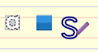  Then practice yourself using the pen tool :   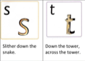 | 15 minutes every other day
Maths
Monday | Mental/Oral Starter – Practice counting in 1’s to 100. Use the count to 100 video link below to help you practice:  https://www.youtube.com/watch?v=bGetqbqDVaA  (Remember to watch the teacher video available to help you with this session)  Main:  This week we are going to be looking at subtraction and using lots of different methods. Today we are going to be using our dienes to help us. When we were adding last week, our answers got bigger. What happens to our answer when we subtract? (The number gets smaller)  Let’s take a look at a subtraction question:  16 -3 =  Read the number sentence.  What do we know about this question? What could we do?  First we need to identify the biggest number. (16) Then we need to partition that number into our tens and our ones using our dienes. Take a look at the example below.  T O T O  1 3  3  =  -  1 6  We now need to look at the number we are taking away (3). We are taking away 3 ‘ones’ so we need to cross out three ones.  To get our answer, we now need to count how many there is left all together.  - I have still got 1 ten  - Now, I only have 3 ones.  - 1 ten and 3 ones = 13  Activity – LO: To subtract (Practical) using dienes.  Using the purple mash 2do work out the subtraction questions on your sheet. Use the dienes to create the biggest number and then take away the smaller number to get your answer. An example has been done for you below. Remember to look at the videos on your class page to help you.  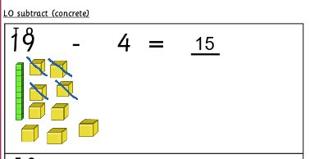 | 45 minutes
Tuesday | Mental/Oral Starter – Practice your number bonds to ten:  1 +_ = 10  2 +_ = 10  3 +_ = 10  4 +_ = 10  5 + _=10  6 +_ =10  7 +_ =10  8 +_ =10  9 + _ =10  10 + _ = 10  Input  Today we are going to carry on with our subtraction but we are going to use the ‘part-whole model’ to help us. We have used the part-whole model before. Take a look at it below. Can you remember the names of the different parts of it?  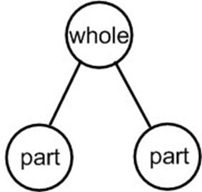  The biggest circle is called the whole – That’s where our biggest number goes.  The smaller circles are called the parts.  Take a look at the subtraction number sentence below. Let’s put it into the part-whole model:  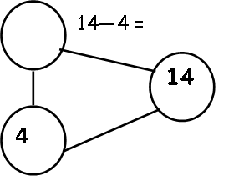  10  - 4 = 10  1  14 is the biggest number so that goes in the whole. We are now going to work out the answer using dienes just like we did yesterday.  We make the biggest number in dienes and subtract the smaller number away from it.  14 – 4 = 10. We can then put the answer into our part-whole model.  (Remember to watch the teacher video available to help you with this session)  Activity – LO: To subtract using the part-whole model (Pictorial)  Use the dienes to solve the subtraction questions and input the answer into the part-whole model. The first one has been done as an example for you. | 45 minutes
Wednesday | Mental/Oral Starter – Practice counting in 2’s and 10’s. Use the video’s to help you :  https://www.youtube.com/watch?v=UfvIlQNlBH4&t=28s  https://www.youtube.com/watch?v=3yf3xgE8wMc  Input –  Today we are going to continue with subtraction but using another method – A tens frame. Take a look at the tens frame below. Can you remember how we use it?  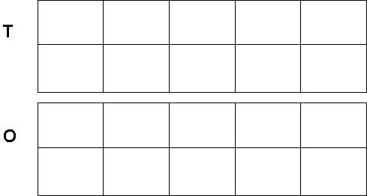  We use one tens frame as to show our tens and the other tens frame to represent our ones. Today we are going to be using a tens frame to answer subtraction questions. Take a look at the example below:  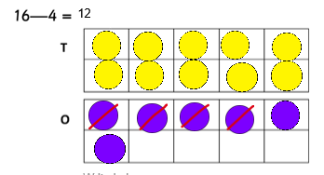  16 – 4 =  First we make the biggest number (16) using counters partitioning into tens and ones.  Then we cross out the number of counters we are taking away (4)  Count together how many counters we have left to get the answer.  Activity – LO: To subtract using a tens frame.  (Remember to watch the teacher video available to help you with this session)  Use the tens frame to solve the number sentences. Make the biggest number on your tens frame, and cross out the number of counters that you are taking away. The first one has been done as an example for you. | 45 minutes
Thursday | Mental/Oral Starter – Find ten more and ten less of the following numbers:  11  16  24  32  Input – Today we are going to be using a number line to help us with our subtraction questions. We have used a number line before to help us with our addition questions.  Take a look at the question below:  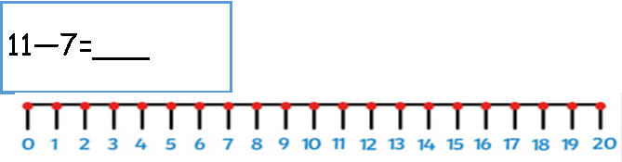  Circle the biggest number first (11). Then jump backwards the number you are taking away (7) When we are doing subtraction questions are number always gets smaller so we will be jumping backwards on our number line.  Activity – LO: To subtract using a number line.  (Remember to watch the teacher video available to help you with this session)  Use the number line to solve the different subtraction questions. Remember to circle the biggest number first and jump backwards the number that you are taking away. | 45 minutes
Friday | Mental/Oral Starter –. – Practice counting in 2’s and 10’s. Use the video’s to help you :  https://www.youtube.com/watch?v=UfvIlQNlBH4&t=28s  https://www.youtube.com/watch?v=3yf3xgE8wMc  Input – Think about all of the different methods we have looked at this week to help us solve subtraction questions. Which did you find easiest? Which did you find a little trickier?  Today you are going to solve lots of different subtraction questions on purple mash using your favourite method.  Activity – LO: To solve different subtraction questions (Quiz)  (Remember to watch the teacher video available to help you with this session)  Log onto purple mash and have a go at the subtraction questions quiz. Choose your favourite method that we have practiced this week and see how many questions you can get right. | 45 minutes
Foundation Subjects
Science | LO: To sort animals into groups based on what they eat  Mental/Oral Starter: Have a think back to last week’s learning. What animal groups can we remember? Write them down. Can you think of a couple examples of each?  Main :  Today we are going to be grouping animals thinking about they eat. Use the bbc bitesize video’s to explore the different types of animals and what they eat :  https://www.bbc.co.uk/bitesize/topics/z6882hv/articles/z96vb9q  There are three groups:  - Herbivores- Any animal that eats only plants will be classified as an herbivore.  - Carnivores - Any animal that eats only meat is classified as a carnivore.  - Omnivores - Any animal that can eat both plants and meat is an omnivore.  Activity:  Now we have learnt a little bit more about what animals eat and what they are called, we are going to group them based on what they eat. Place the animals carefully in the correct boxes. (Using the animals in the clipart bin if on purple mash). An example has been done for you below:  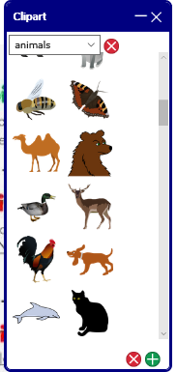  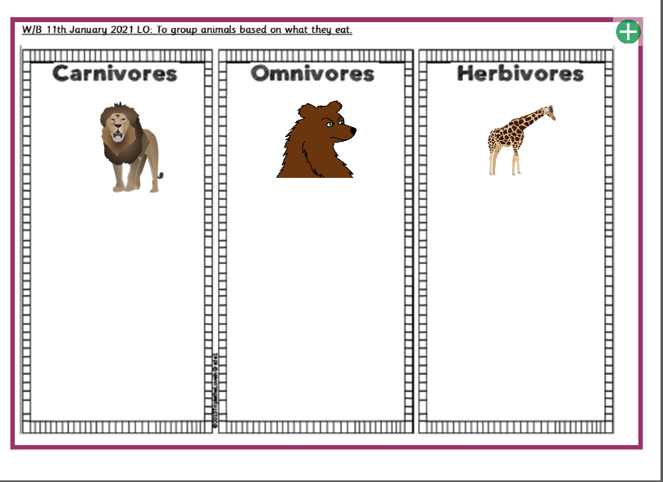  A lion is a Carnivore because it eats only meat  A bear is an example of an omnivore because we eat BOTH plants and meat.  A giraffe is an example of a herbivore because it eats only plants.  Plenary:  Do some research – What group would a human fit into? Is it an omnivore, herbivore or carnivore? | 1 sessions  30 minutes
Art | LO: To identify primary colours  Mental/Oral Starter: This half term in art we are going to be looking at primary and secondary colours. What is your favourite colour? Discuss with your family – What are their favourite colours?  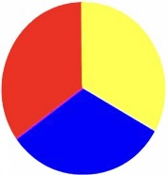  Main: Today we are going to be looking at primary colours. The 3 primary colours are:  - Red  - Yellow  - Blue  Primary colours are colours that when combined can be used to make lots of different colours.  Activity :  For this activity we would love for you to log onto purple mash and click onto your ‘2do’s.’ Paint a picture using JUST the primary colours (Red, yellow and blue)  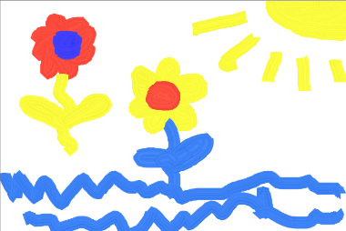  (Example picture using JUST primary colours)  Plenary  Our next art lesson will look at the secondary colours – Do some research. Can you find out what the secondary colours are? | 1 sessions  30 minutes

Please support your children at home and if you require printed copies of home learning please don’t hesitate to contact the school reception who will inform us and we can arrange for this to get to you. We love seeing your children’s learning so please ensure you bring this learning in for us to see!

Thank you for your support.
Miss Hobson and Mrs Kausar

