Learning Base 1 News
Spring 1 2021
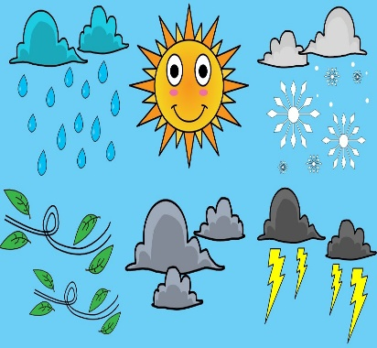
We are ready for a new year and a term full of exciting learning.
Our new topic……..Weather
During our topic this half-term we will be looking at ‘Weather’. We will be looking at the different types of weather and what clothes we wear.
The children will be exploring the different types of weather through art and sensory based activities.

How you can help at home…
*PLEASE continue to talk about what you notice in the world around you. Label the weather and ask your child what they need to wear.

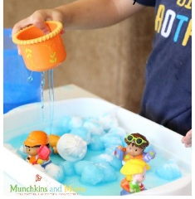
In Literacy…
The children will be looking at fiction and non-fiction books about ‘Weather’. Each week they will join in with a sensory story about a different weather type.

How you can help at home…
*Read every day with your child. This can be just looking at the pictures in the book and asking your child to point out an item, to stories with actions.
*Show and read to the children Environmental print around them, e.g. Shop signs
*Play turn taking games and model language at all times.

In Maths
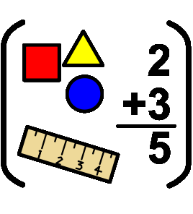
The children will be working on their individual Maths targets in class. They will be using lots of practical resources to help develop their knowledge and understanding.

How you can help at home…

*Count out objects when playing or cooking
*Encourage your child to set the table, modelling counting for them.
*Name different shapes, sizes and colours you see.
Thank you for your continuing support.

